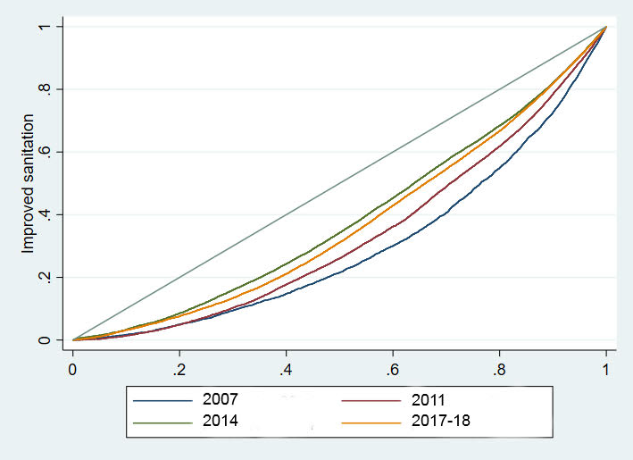

**Figure 1: Equity distribution of improved sanitation utilisation over the time from 2007 to 2017-18**